Why not generating multiple plan in Planner agent like mapcoder:
MapCoder's ranking has a real weakness worth naming directly: it asks the same LLM that wrote the plan to self-assess how confident it is, before any code has run. That's exactly the kind of unverified self-judgment Huang et al. (2024) found unreliable and we've seen it directly in our own data: qwen stated a "FINAL ANSWER" with full apparent confidence while the value was fabricated. Self-reported confidence isn't grounded in anything real.
It's more token-efficient MapCoder's own limitations section admits they never solved the cost of generating k plans upfront when most go unused; this avoids that entirely.
It's better grounded in the Huang et al. (2024) finding what makes iteration help is external, verified feedback, not just having more options to choose from. A fresh plan, based on the feedback of the produced result, written in direct response to a concrete, real failure is exactly that; picking from a pre-generated shelf of untested plans isn't.

How our Coding + Validation genuinely differs from MapCoder's Coding + Debugging a real, fundamental distinction, not just a naming choice

The critical difference: MapCoder's test() function checks code against known, ground-truth sample input/output pairs competitive programming problems come with worked examples (sum_squares([1,2,3]) == 14) that the code can be checked against before the model commits to a final answer.
Our task structurally cannot do this. The real Moran's I value is the thing we're testing whether the model can compute handing it over as a "sample answer" to check against would make the whole experiment circular. There is no equivalent of a sample I/O for "is this borough's spatial clustering significant."
This means our Validator can only ever check mechanical plausibility, never substantive correctness. It can catch nan, an impossible p-value, or a hardcoded literal but it cannot catch a well-formed, finite, correctly printed number that's simply the wrong method. Recall gpt-4o-mini's sign-matching proxy on the change-spillover NO2 case real, finite, correctly printed, and it would pass every one of our checks, despite being analytically weaker than real Moran's I. This is a genuine, honest limitation worth stating plainly in the thesis, not glossing over and it's precisely why MapCoder's approach doesn't transfer directly: they have access to objective ground truth pre-answer; open-ended statistical inference on real data does not.

Justifications: Issues needed to be addressed through multi agent framework (Generic)
2. The 5 validation checks - table for your supervisor
Check | What it actually does | Why it's generic
1. Finite statistic | Confirms the model's main reported number is a real, finite value - not text, not missing | Never references what the number means or which method produced it - works for any statistic, any task
2. Finite secondary measures | If a second number was reported (e.g. a p-value), confirms it's also finite | Doesn't assume every task needs a second number - only checks it if one was given
3. Real variable reference | Confirms the final answer's number was pulled from an actual computed variable in the code (an f-string with a placeholder), not typed by hand as a guess | Checks code structure only -applies to any statistic, any print statement
4. Data-points reconciliation | Confirms the number of data points the model claims to have used matches what the dataset actually contains  Data counts (from file read)– missing from planner agent == data points found by coder | Uses only row_count and data_points_used - concepts every task already reports, regardless of subject matter
5. Determinism | Re-runs the model's exact code once, independently, and checks the result matches catches hidden randomness or bugs | Just compares two numbers from the same code - no task-specific logic involved

Common model mistakes found:
- Standardization calculation: value - average (a direct deviation from the mean) this is the Outlier Detection (Iterative-R) task's core formula: z = (target_value - mean_of_neighbors) / std_of_neighbors. A model that drops the subtraction and just uses the raw value computes a meaningless number

- Variance calculation: n×(n-1) (a sample-size-dependent normalization term) this belongs to Moran's I and Getis-Ord Gi* (used in Spatial Correlation, Spatial Hotspot, Cross-variable/Bivariate Clustering, and Spatiotemporal Change Clustering). Their variance formulas, under the standard randomization assumption, require this term to correctly scale expected variance for the number of boroughs involved. Dropping it and using plain n produces a systematically wrong variance

Scoring logic

A chunk only counts as "evidenced" if a real, finite number was cited (rejects nan, self-admitted non-computation phrases like "could not compute")
outlier_magnitude_plausible(): rejects cited values > (2* ground truth value), grounded in the real observed ground-truth max a task-specific, If used other statistical method count them true if a finite number is cited. Some cited values are showing too big numbers.
verdict_z_consistent(): rejects cases where the verdict contradicts the model's own cited value (e.g. a z=2.4 result labeled "not an outlier") but only when the label is confidently a standard z-score (not t, R, M, or other ambiguous method names the task explicitly permits)

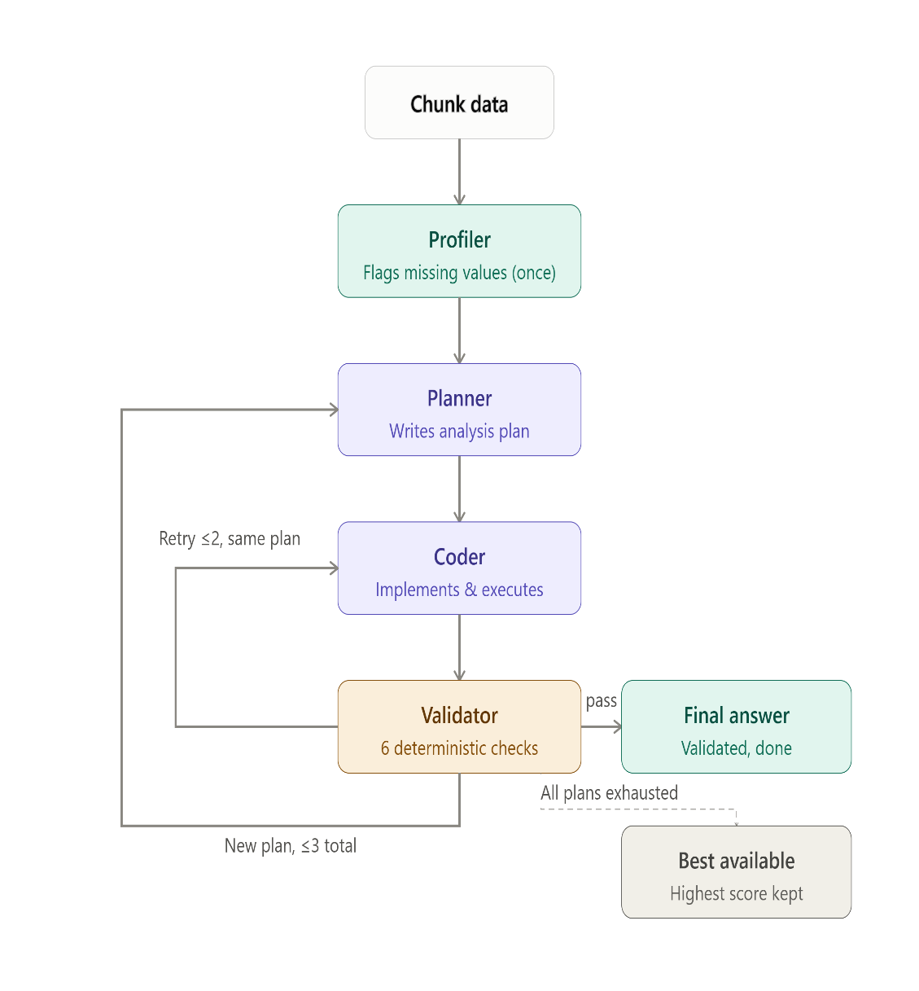

User prompt
I've attached NO2 values for 33 London boroughs for the years 2021, 2022, and 2023, and a list showing which boroughs are geographic neighbors of each other.

Question: Do boroughs that saw a large CHANGE in NO2 between 2021 and 2022 tend to be located near other boroughs that ALSO saw a similarly-sized change in the SAME direction (both increasing, or both decreasing), or does a borough's change show no relationship to its neighbors' changes? This tests whether the CHANGE itself clusters spatially, not just the raw level in any single year.

(Note: the data includes a third year not needed for this question.)

Explain your reasoning based on the data, including the actual computed statistic and its significance. You can use a statistical method such as Global Moran's I, or another appropriate method of your choosing, to support your conclusion.

Note: dedicated spatial-statistics packages (pysal, esda, libpysal, geopandas, or similar) are NOT installed in this environment -- don't spend turns trying different import paths for them. Implement your chosen method directly using only pandas and numpy. If you test statistical significance via a permutation/randomization test, use at least 500 random shuffles -- fewer permutations can produce an unstable p-value that lands on the wrong side of the 0.05 threshold just by chance, especially when the true effect is only moderate.

End your response with exactly one line, including the computed number(s) you used:
FINAL ANSWER: CLUSTERED (test statistic = <value>, p = <value>)
or
FINAL ANSWER: NOT CLUSTERED (test statistic = <value>, p = <value>)
(test statistic is just an example label -- if your method produces a different statistic, use its name instead, but the value after '=' must be a real number)

System prompt

Single Agent
SYSTEM_PROMPT = """You are a single AI agent responsible for the entire analysis pipeline:
profiling the dataset, planning the analysis, writing and running code, and reporting results.
You must ground every claim in code output -- never guess numbers. Always print() the numbers
you compute so they appear in the tool output."""

Multi agent
profiler
prompt = (
"You are the Profiler. Explore this dataset with real, executed "
"pandas code -- do not guess or describe from the preview alone. "
"For every numeric column, print its missing-value count using "
"EXACTLY this format, one line per column:\n"
"missing_count_<column_name> = <integer>\n"
"Then print the total row count using EXACTLY this format:\n"
"row_count = <integer>\n"
"Do not analyze or answer any question -- only report these facts "
"about the data itself, using the exact print formats above."
f"\n\nDataset path: {dataset_path}\n"
"Write ONE ```python``` block that loads the data and prints "
"these facts. Re-import pandas/numpy; this runs in a fresh "
"process.\n" + preview)
Planner:
prompt = (
"You are the Planner. Write a short, numbered plan (steps only, "
"no code) for answering this question, using the real data facts "
"below. Your plan should explicitly state how missing values "
"will be handled if any exist. Do not write a FINAL ANSWER line "
"or invent any specific numbers -- describe the approach only, "
"the actual values will come from real computation later.\n\n"
f"Question: {question}\n\nData profile:\n{profile_text}"
f"{retry_block}"
)

Coder:
prompt = (
"You are the Coder. Implement this plan with real, executed "
"pandas/numpy code. Your code must print:\n"
"1. `data_points_used = <integer>` -- the exact number of data "
"points used in your FINAL calculation (after excluding any "
"missing values)\n"
f"2. {format_instructions}\n\n"
f"Question: {question}\n\nData profile:\n{profile_text}\n\nPlan:\n{plan}"
f"{retry_block}\n"
"Write ONE ```python``` block. This runs in a fresh process; "
"re-import pandas/numpy and reload the data.\n" + preview )
Scoring logic:

For Bivariate:
Change | What it does
_resolve_ground_truth() | Per row, tries the row's own statistical_method against ground_truth_all_methods.csv first; falls back to the manifest's Lee's L only if that method has no computed ground truth
correct (primary) | Now checked against gt_direction_used — the resolved, method-matched truth — not always Lee's L
correct_vs_manifest (new, secondary) | Kept as an always-Lee's-L comparison so you still have "did it answer the official question" as a separate reportable number
ground_truth_source | "method_specific" or "manifest_fallback" per row — fully auditable, surfaced in the summary as n_method_specific_gt / n_manifest_fallback_gt
Confusion matrix / F1 | Now use gt_direction_used too, so they're consistent with the primary correct column instead of silently disagreeing with it
Tolerance | 10% relative / 0.02 absolute, with the per-method justification/caveat written directly into the docstring

For variance:
Good — let me actually derive a number instead of guessing at one. I can run a simulation right now: generate spatial data with a network structurally similar to your London borough adjacency (33 nodes, realistic connectivity via Delaunay triangulation), then measure how much Lee's L and Cross-Moran's I actually differ between two legitimate weight-matrix conventions (row-standardized vs. binary) across many random draws. That gives an empirically-grounded tolerance instead of a round number I picked.
This is a much better basis than a guessed number — and it revealed something important: relative tolerance is the wrong metric entirely for these statistics. Because Lee's L and Cross-Moran's I are often close to zero, relative error blows up (a stat of 0.01 vs 0.02 is "100% relative difference" but a trivial absolute difference). The absolute differences are stable and interpretable instead:
Method | Median abs diff | p90 | p95
Lee's L | 0.012 | 0.033 | 0.044
Cross-Moran's I | 0.012 | 0.031 | 0.037
So: switch from relative to absolute tolerance, set at 0.05 for the spatially-weighted methods — that covers roughly the 95th percentile of legitimate row-standardized-vs-binary variation in this simulation, while still being far tighter than the multi-hundred/billion-magnitude gaps we saw from broken runs. For Pearson, I'll set it much tighter (0.01) since it has no such ambiguity — that case is rare in your data anyway, per your note.
Updating the script accordingly:
Clean — no leftover references. Also including the sensitivity simulation script itself so you have it for your methodology appendix (and can re-run it against the real borough adjacency instead of the synthetic Delaunay stand-in, which would tighten the number further):
Summary of the change:
Method | Old (guessed) | New (empirically derived) | Basis
Lee's L | 10% relative | 0.05 absolute | p95 of simulated row-standardized vs. binary weight variation ≈ 0.044
Cross-Moran's I | 10% relative | 0.05 absolute | p95 ≈ 0.037
Univariate Moran's I | 10% relative | 0.05 absolute | applied same figure — hasn't been separately validated, but same weight-matrix mechanism applies
Pearson correlation | 10% relative | 0.01 absolute | no legitimate convention ambiguity — floating-point margin only
One honest limitation to state alongside this in your thesis: the simulation uses a synthetic Delaunay-triangulated network (33 nodes, comparable density) as a stand-in for the real London borough adjacency graph, since I don't have your actual borough_adjacency.csv here. If you run sensitivity_sim.py locally with the real adjacency structure substituted in, you'd get a number tied specifically to your data rather than a structurally-similar proxy — worth doing before finalizing this in the thesis, even though I'd expect the real figure to land close to this one given comparable network density.

For Hotspot (Geoisord)

Final scoring logic — one table, plain English
Column | What it measures | Justification
accuracy | Per-chunk F1, averaged across all chunks — full credit for an exact match, partial credit for a partial one | Chosen over strict exact-match (checked directly against your data: stays at 0 for any model that isn't hitting the true set exactly) and over Youden's J (its penalty is diluted by the large pool of non-significant boroughs, so it barely punishes over-guessing here). F1 penalizes misses and false alarms symmetrically — the closest citable match to "credit per hit, penalty per miss."
correct_number | Raw count of chunks with a perfect exact-set match | Kept from the original script, unchanged — gives you the strict view without needing a separate ratio column for it.
precision / recall / f1 | Same idea as accuracy, but pooled across the whole model's output rather than averaged per chunk | Unchanged from the original script — shows overall calibration (does the model systematically over- or under-guess).
partial_accuracy | Overlap ÷ union of predicted and true boroughs (Jaccard) | Unchanged from the original script — a stricter partial-credit alternative sitting alongside accuracy.
n_method_specific_gt (new) | How many chunks were scored against ground truth for the exact method that row used, vs. falling back to the manifest's Gi* answer | Without this, there's no way to tell whether a model's score is method-matched or a fallback comparison — directly load-bearing for the method-resolution logic you asked for earlier.
accuracy_fully_verified (new) | Fraction of chunks that are correct, evidenced, AND have every reported number within tolerance of the ground truth | The one column that can't be gamed by a lucky guess or a fabricated number — the strictest, most trustworthy metric in the table.
Matching (unchanged from last message, since it wasn't the actual cause of the zero): a borough counts as identified by name only — hot/cold direction is not checked, per your instruction.

For outlier detection

Scoring logic — what changed and why
Kept exactly as you had it (these were real fixes, not something to touch):
Check | What it catches
verdict_z_consistent | A verdict only gets penalized against its own reported number when the number's label confidently identifies it as a z-score or p-value — not guessed from magnitude alone. Fixes the real false positive where "z = 0.031" was misread as a significant p-value.
outlier_magnitude_plausible | Flat 12.0 ceiling (≈2× the real observed max of 5.54 across the manifest). Catches genuinely-computed-but-broken answers, like the z=30.41 masking-bias-omission case, without penalizing correct direction.
New, layered on top:
Column | Logic | Why
correct / accuracy | Predicted class == ground truth for the specific method that row used (from ground_truth_all_methods_outlierr.csv), not always Iterative-R | A row using Local Moran's I should be judged against what Local Moran's I actually says, not against a different statistic's answer
n_method_specific_gt | Count of chunks scored against a method-matched ground truth vs. the Iterative-R fallback | Transparency — shows how much of a model's score rests on which comparison
accuracy_fully_verified | correct AND evidenced AND reported z-value within absolute tolerance of the resolved ground truth | The strictest metric — can't be gamed by a lucky directional guess
Tolerance is absolute, not relative — same reasoning as getisord: relative error blows up meaninglessly near zero (a z of 0.05 vs 0.1 is "100% relative error" but a trivial real difference). Values are method-specific because the source of legitimate implementation variance differs: regression-based methods (Iterative-R, single-pass, robust) can differ by which residual convention is used (standardized vs. studentized — empirically measured at p95 = 0.073, so 0.1 tolerance), the neighbor mean/std z-score has no such fitting ambiguity so gets a tighter 0.05, and Local Moran's I reuses getisord's 1.5 since it's the identical statistic with the identical analytic-vs-permutation variance-estimation spread.

For changespliover

score_changespillover.py (binary: CLUSTERED / NOT CLUSTERED, single global test per chunk)
Column | What it measures | Justification
accuracy | Predicted CLUSTERED/NOT CLUSTERED == ground truth for the specific method that chunk used (Global Moran's I, Geary's C, Join Count, or Neighbor-average correlation), with fallback to the manifest's Global Moran's I answer if the method has no computed ground truth | Judges a model's conclusion against what its own chosen method actually says, not always against Moran's I
precision / recall / f1 | 2-class macro-averaged (CLUSTERED and NOT CLUSTERED each scored as their own class, then averaged) | Prevents a model from hiding poor CLUSTERED-detection behind good majority-class guessing; also closes a real blind spot in the original single-class version, where an ambiguous row could only ever hurt F1 when the true answer was CLUSTERED
tp / fp | Raw counts for the CLUSTERED class only | Descriptive only — kept for reference, not the basis of precision/recall anymore
pct_with_evidence | Fraction of rows with a real, non-fabricated statistic, a valid probability, and a p-value consistent with the claimed verdict | Same evidence-fabrication check used across every task this session
n_method_specific_gt (new) | How many chunks were scored against ground truth for the exact method used, vs. the Global Moran's I fallback | Transparency — shows how much of a model's score rests on a method-matched vs. fallback comparison
accuracy_fully_verified (new) | Correct + evidenced + reported statistic within 0.05 absolute of the resolved ground truth's value

For spatial correlation analysis

Scoring logic — plain-English table (columns unchanged from before)
Column | GLOBAL rows | LOCAL rows
correct | 1.0 if predicted CLUSTERED/NOT matches resolved ground truth, else 0.0 (unchanged) | Per-chunk F1 between the model's cited borough names and the manifest's significant_cluster_boroughs — credit per correct name, penalty per wrong one, naturally bounded [0,1]
correct_number / accuracy | Same formula as before (sum(correct)/n) | Same formula — now blends exact 0/1 credit (global) with partial credit (local) automatically
tp / fp | Chunk-level CLUSTERED-class counts (unchanged) | Borough-level counts, pooled across every local chunk, added into the same totals
precision / recall / f1 | Macro-averaged over CLUSTERED / NOT_CLUSTERED (unchanged) | A third pseudo-class, LOCAL_BOROUGH_MATCH, averaged in on equal footing with the other two
pct_with_evidence | Unchanged | Unchanged

adjustment between proposal and thesis
Dear teaching team,
I am writing to seek clarification regarding minor procedural adjustments for my final thesis.
Following recent discussions with my supervisor, we agreed that certain aspects of the project plan outlined in my submitted research proposal need refinement:
Feature Selection Adjustment: We identified the need to modify the feature selection strategy. Could you please clarify if I need to submit an amended proposal, or if it is acceptable to directly incorporate and justify these changes within the final thesis?
Data Analysis Workflow: We are planning to adjust the specific data analysis pipeline while keeping the core research questions and research objectives unchanged. Could you confirm whether formal approval/resubmission is required for updating the analysis workflow under this condition?
Best regards,

Dulan Perera
Last week
If the changes are minor and are still reflected in your current thesis title, you do not need to change the title or resubmit the proposal.
However, if you would like to update the thesis title to better reflect the changes, you will need to submit a thesis title change request to the CE of the unit, briefly explaining the reason for the change. Please also CC me and your supervisor on the email.

